Pressing Q toggles the automatic camera track, cycling around the scene and then doing a topdown view

Pressing T toggles the track of the light causing shadows on the scene.

This light loops over and under the scene like a daylight cycle. T will pause this

Pressing B will toggle the full scene gaussian blur. This has 10 passes.

Bandicam caused a few issues with recording as well as Ness being ness and not accepting files / doing it slowly

Scene contains the following features:

Deferred rendering

Multiple point lights

Shadow mapping on whole scene + models

Skeletal animation with shadow mapping and reflections to point lights

All models minus the heightmap and water are in a scene node list

Frustum culling for buildings and armoured people

Texture stencils combining diffuse and normal maps

Camera tracked skybox with accurate reflections in the water in the scene.

Automated camera movement with rotation

Whole screen gaussian blur (from tutorial)

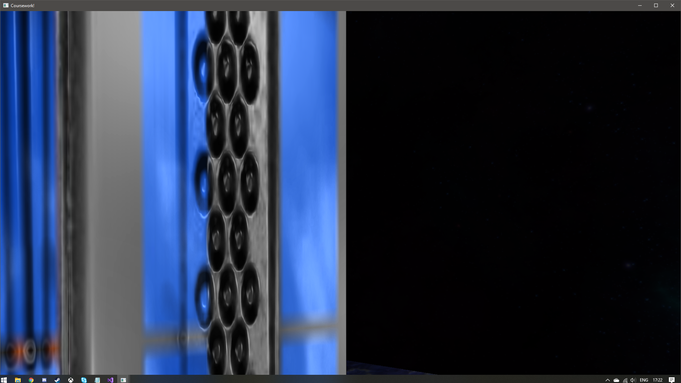  
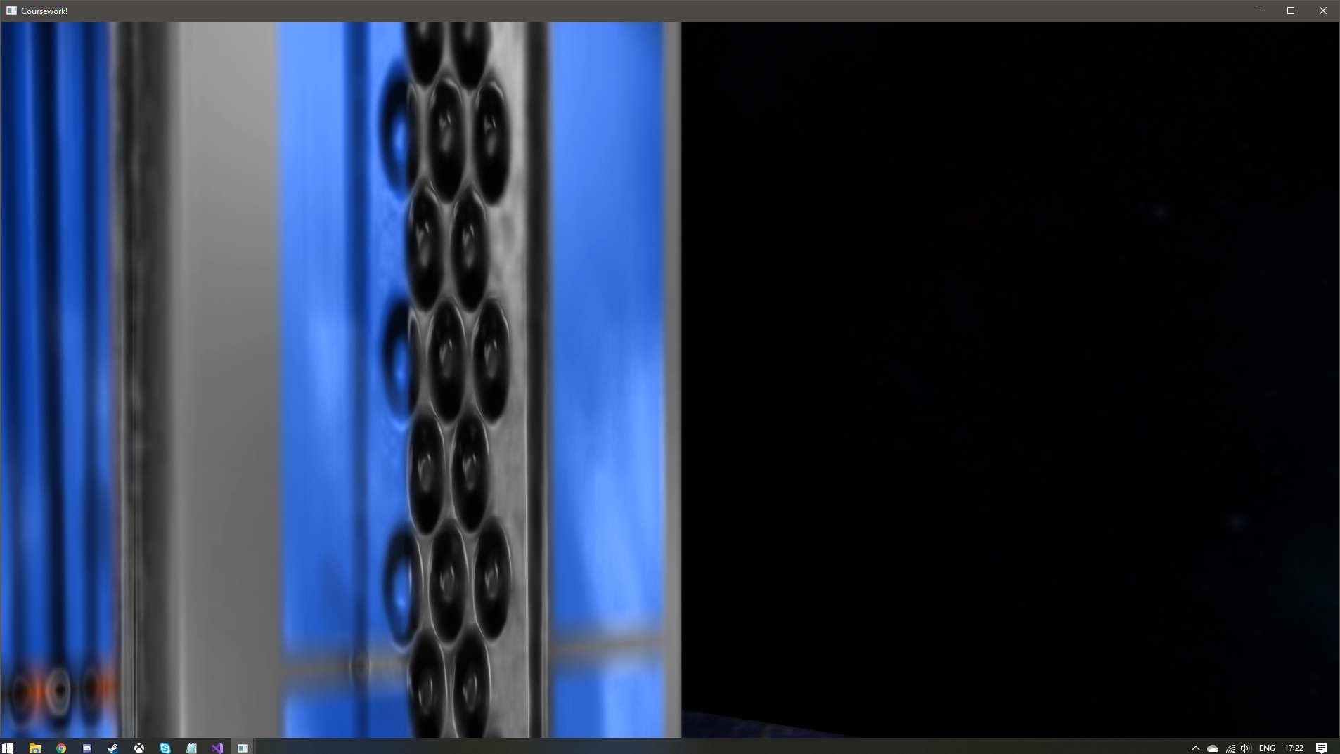

Close up of the blur effect on a hard edge

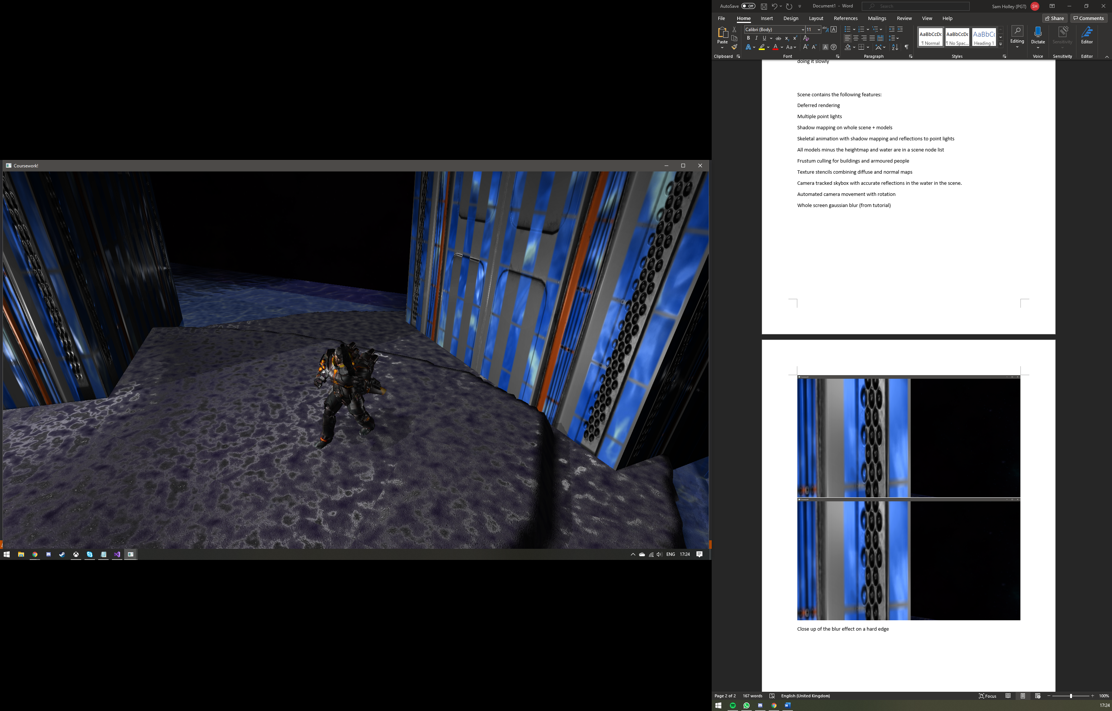

Shadows cast from the heightmap, buildings, and models can be seen here. Light was paused

Models outside of the frustum still produce shadows, although the shadows cast don’t include any animations (For the soldier).

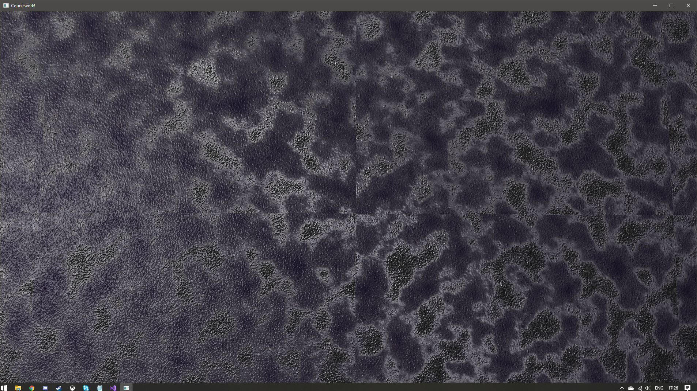

Example of texture stencilling. Patches of a rough surface mixed with patched of a smoother surface with normal maps merging too.

Should’ve used a repeating noise texture for this as the seams are visible where the noise repeats.

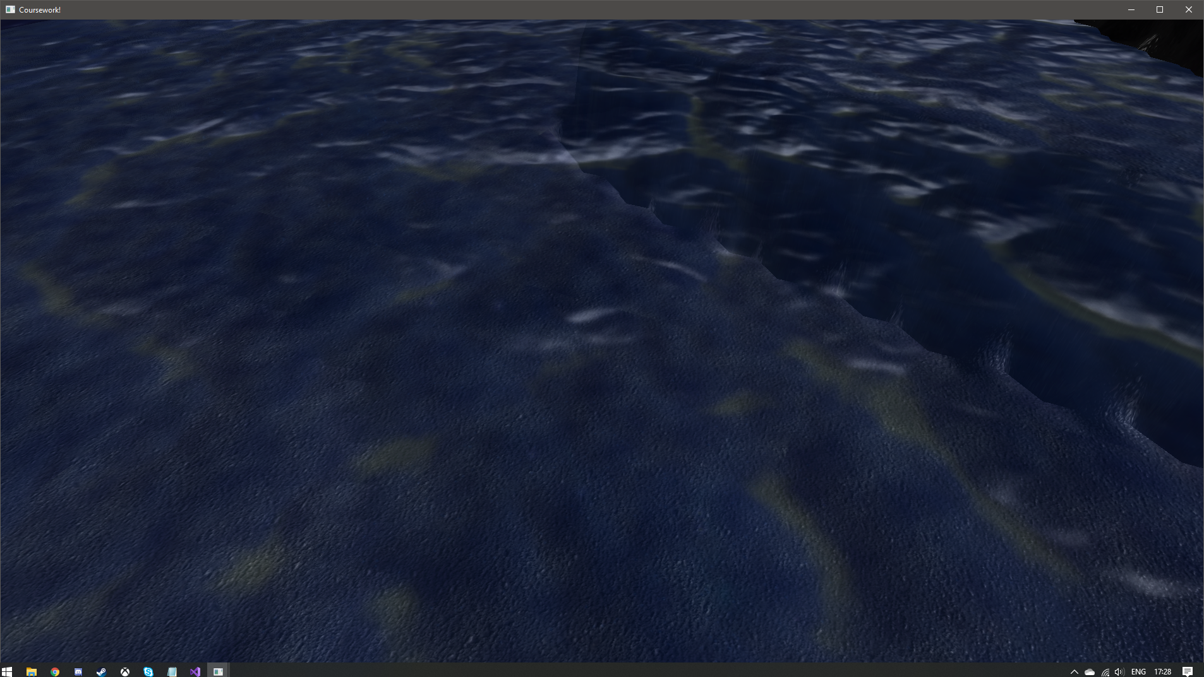

Small spots can be seen on the surface of the water, corresponding to reflections of the stars from the skybox. Easier to tell apart from the water texture when it is moving.